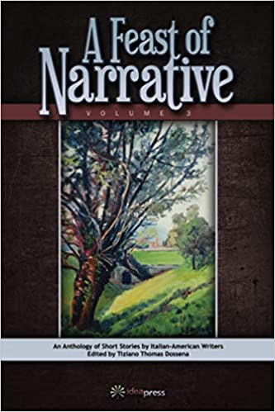
ANTHOLOGY
A FEAST OF NARRATIVE VOLUME THREE
ORDER FORM

$18.00 A COPY, SHIPPING AND TAXES INCLUDED
Name:
Address:

Telephone Number:
Email:

Number of copies ordered:
Make Check out to: Idea Graphics LLC.

