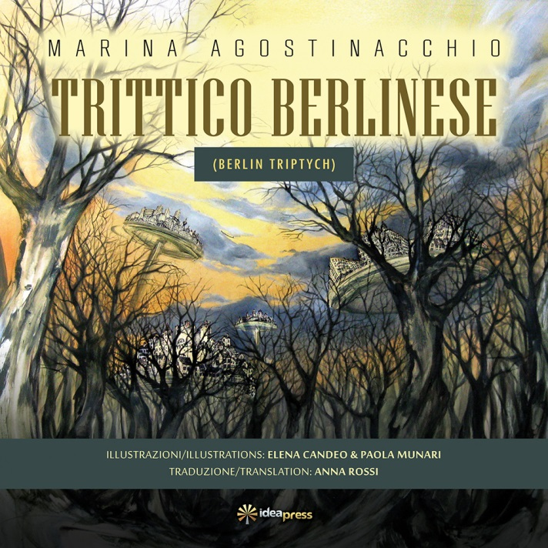
TRITTICO BERLINESE

USA: $18.00 A COPY, SHIPPING AND TAXES INCLUDED
Name:
Address:

Telephone Number:
Email:
Number of copies ordered:
Make Check out to: Idea Graphics LLC.

