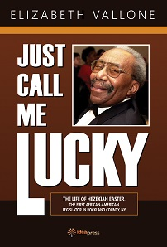
Just Call Me Lucky Order Form

Name:
Address:

Telephone Number:
Email:

Number of copies ordered:
Make Check out to: Idea Graphics LLC.

